Artificial Intelligence Lab

Lab Manual 08



Department of Cyber Security

HITEC University Taxila

1. Introduction
Game theory helps us understand decision-making in environments where multiple players interact, each with their strategies and payoffs. In this lab, students will learn and implement in Python.

2. Objectives
- To understand the concept of game trees in AI.
- To implement the Min-Max algorithm for two-player games.
- To optimize the search using Alpha-Beta Pruning.
Software
- Python, Pycharm or VS-Code IDE

3. Theory

3.1 What is Game Theory?
Game Theory is a branch of mathematics that studies decision-making in situations where multiple agents (players) interact with each other, and the outcome for each agent depends not only on their own decisions but also on the decisions made by others.
In Artificial Intelligence (AI), Game Theory is used to model and analyse the behaviour of rational agents in competitive or cooperative environments.

3.2 Minimax Algorithm
Minimax is a kind of backtracking algorithm that is used in decision making and game theory to find the optimal move for a player, assuming that your opponent also plays optimally. It is widely used in two-player turn-based games such as Tic-Tac-Toe, Backgammon, Mancala, Chess, etc.
- MAX: Player who tries to maximize the score.
- MIN: Opponent who tries to minimize the score.

Chess | Tic-Tac-Toe | Backgammon
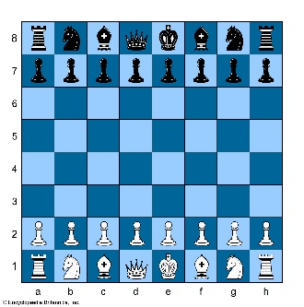 | 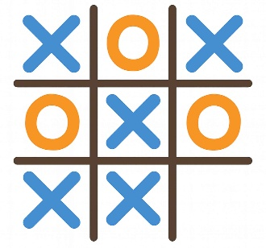 | 

How It Works:
- Build the game tree to a certain depth.
- Assume that both players play optimally.
- Evaluate the game states from the bottom up.
- MAX chooses the move with the maximum value.
- MIN chooses the move with the minimum value.

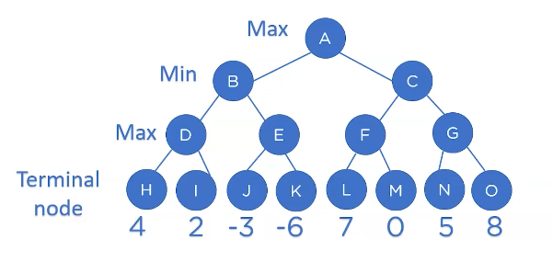
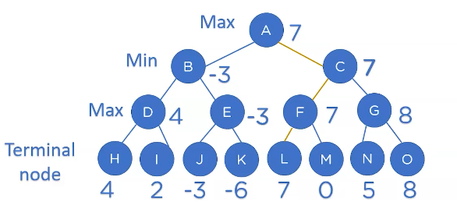

3.3 Implementation in Python
import math
# Minimax function
def minimax(depth, nodeIndex, isMax, scores, targetDepth):
# Base case
if depth == targetDepth:
return scores[nodeIndex]

if isMax:
return max(
minimax(depth + 1, nodeIndex * 2, False, scores, targetDepth),
minimax(depth + 1, nodeIndex * 2 + 1, False, scores, targetDepth)
)
else:
return min(
minimax(depth + 1, nodeIndex * 2, True, scores, targetDepth),
minimax(depth + 1, nodeIndex * 2 + 1, True, scores, targetDepth)
)

# Terminal node values from left to right: H, I, J, K, L, M, N, O
scores = [4, 2, -3, -6, 7, 0, 5, 8]

# Calculate depth = log2 of the number of leaf nodes
treeDepth = int(math.log2(len(scores)))

# Start Minimax
optimalValue = minimax(0, 0, True, scores, treeDepth)

print("The optimal value is:", optimalValue)

Output:
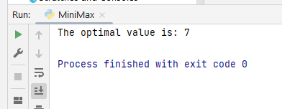
Code Explanation:
Initial Call:
minimax(0, 0, True, scores, 3)
- Depth = 0 → root (A, Max turn)
- Index = 0
We will explore both children of A:
- Left → B (nodeIndex = 0 × 2 = 0)
- Right → C (nodeIndex = 0 × 2 + 1 = 1)

Step-by-Step Run

Left Subtree (B - Min):
minimax(1, 0, False, scores, 3)
→ Left Child of B (D - Max):
minimax(2, 0, True, scores, 3)
→ Left child of D (H):
minimax(3, 0, False, scores, 3) → depth == 3 → return scores[0] = 4
→ Right child of D (I):
minimax(3, 1, False, scores, 3) → return scores[1] = 2
D returns: max(4, 2) = 4

→ Right Child of B (E - Max):
minimax(2, 1, True, scores, 3)
→ Left child of E (J):
minimax(3, 2, False, scores, 3) → return scores[2] = -3
→ Right child of E (K):
minimax(3, 3, False, scores, 3) → return scores[3] = -6
E returns: max(-3, -6) = -3
B returns: min(4, -3) = -3

Right Subtree (C - Min):
minimax(1, 1, False, scores, 3)
→ Left Child of C (F - Max):
minimax(2, 2, True, scores, 3)
→ Left child of F (L):
minimax(3, 4, False, scores, 3) → return scores[4] = 7
→ Right child of F (M):
minimax(3, 5, False, scores, 3) → return scores[5] = 0
F returns: max(7, 0) = 7

→ Right Child of C (G - Max):
minimax(2, 3, True, scores, 3)
→ Left child of G (N):
minimax(3, 6, False, scores, 3) → return scores[6] = 5
→ Right child of G (O):
minimax(3, 7, False, scores, 3) → return scores[7] = 8
G returns: max(5, 8) = 8
C returns: min(7, 8) = 7

Final Step: A returns
- A (root, Max): max(-3, 7) = 7

3.4 What is alpha-beta pruning
Alpha-Beta Pruning is an optimization technique for the Min-Max algorithm that prunes (cuts off) branches in the game tree that do not influence the final decision, reducing the number of nodes evaluated.
- Alpha (α): The best value that the maximizer can currently guarantee.
- Beta (β): The best value that the minimizer can currently guarantee.
Pruning Condition:
- If β ≤ α, stop evaluating further descendants.
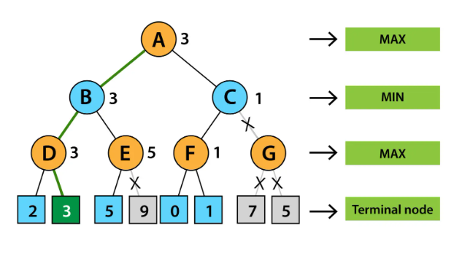

4. Lab Task
1. Apply Alpha-Beta Pruning to the graph.
2. Apply the minimax algorithm in the Tic-Tac-Toe game.
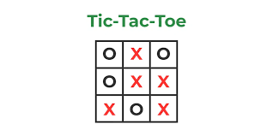

5. Conclusion

